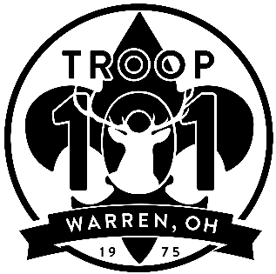
Boy Scout Troop 101

Jason Paisley, Scoutmaster
3002 Reeves Road NE Warren OH 44483
(330) 219-5826
Scoutmaster@Troop101.net

As the legal parent(s)/guardian(s) of ________________________________________________
(Scout’s Name)
I/we do hereby give permission for the leaders of Boy Scout Troop 101, based in Warren, Ohio (USA) to supervise our son and to take him on an expedition into Canada. The dates of this trip are planned from August 5st through August 12th 2023. During this period our son has permission to travel into Canada, and back into the United States of America, with the expected itinerary to include travel to Algonquin Provincial Park, Ontario, Canada, and return to Warren, Ohio, USA.
I/we also give the adult leaders of Boy Scout Troop 101 permission to administer and or request medical assistance for our son if it becomes required, and grant licensed medical staff in both the United States of America and the country of Canada permission to perform such medical care as may be deemed necessary while attempts are being made to reach us. We further give permission for emergency transport of our son to an appropriate medical facility if it should become necessary.
Proof of U.S. Citizenship is attached. (U.S. Passport; OR original birth certificate)
Signed: _____________________________________ __________________________
(Father/legal guardian) (Date)
Signed: _____________________________________ __________________________
(Mother/legal guardian) (Date)

I witness hereof I hereunto set my hand and official seal

_____________________________________
(Notary Public)

My commission expires: _____________________

